Age (years)
Gender (M/F)
Dementia (N/probable/Y)
Specialty (Choose one of: Acute medicine/ Geriatric medicine/ Other medicine/ Stroke/ Other surgery/ General surgery/ Orthopaedic surgery)
Clinical Frailty Scale (1-9) – This should be recorded for their status 2 weeks prior to admission; use all available information including functional history by clerking doctor and/or OT assessment – use guide overleaf
Delirium screening performed in first 48 hours? (N/Y)
If so, who by? (Choose one of: Junior doctor FY1-CT2/ Geriatric SpR or consultant/ Other medical SpR or consultant/ Surgery SpR or consultant/ Nurse, AHP, or other)
Delirium diagnosis in notes? (N/Y)
If yes, duration (days)?
If yes, Incident (not present on admission), or prevalent (present on admission?
If yes, subtype? None/ Hyperactive/ Mixed/ Hypoactive
If no, proceed to full retrospective assessment (not necessary if delirium diagnosed)
Delirium present in retrospective assessment? (N/Y) – use guide overleaf
If yes, duration? (days)
If yes, Incident or prevalent?
If yes, subtype? None/ Hyperactive/ Mixed/ Hypoactive
Length of stay (or time to death if inpatient death)
Inpatient mortality (N/Y)
Discharge destination? (New care home*/ previous care home/ own home/ rehabilitation)
*Care home can be residential or nursing
If delirium diagnosis in notes, was this included on discharge documentation? (N/Y)

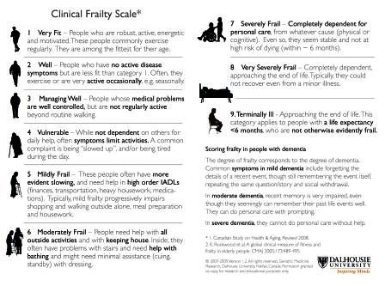
a | A disturbance in;  i) Attention- reduced ability to direct, focus, sustain, and shift attention  FROM: 20-1, MOYB (if done), comments including ”distractible”, “inattentive”, or similar | Yes | No | ?
OR ii) Awareness (reduced orientation to the environment)
FROM: comments including “drowsy”, “agitated”, or similar
b | The disturbance;  i) Develops over a short period of time (usually hours to a few days)
 | Ii) Represents a change from baseline attention & awareness  iii) tends to fluctuate in severity during the course of the day  FROM: documentation as new problem by medical staff, or relative concern | Yes | No | ?
c | An additional disturbance in cognition (e.g. memory deficit, disorientation, language, visuospatial ability, or perception).  FROM: AMTS, MOCA (if done), comments of “confusion”, or similar | Yes | No | ?
d | Exclusions- The disturbance in criteria A and C are;  i) Better explained by another pre-existing, established, or evolving neurocognitive disorder, or ii) Occur in the context of a severely reduced level of arousal such as coma. FROM: History suggestive of progressive condition on admission OR severely obtunded patient e.g. in the context of Type 2 respiratory failure requiring ICU admission | Yes | No | ?
e | There is evidence from the history, physical examination or laboratory findings that the disturbance is a direct physiological consequence of another medical condition, substance intoxication or withdrawal, or exposure to a toxin, or is due to multiple aetiologies.  FROM: Acute illness/precipitant of any description (should be yes for all patients) | Yes | No
 | Probable Delirium Diagnosis – all items a,b,c and e ‘yes’, plus d ‘no’ | Yes | No
 | Possible delirium diagnosis – if any ‘?’ or e ‘no’ | Yes | No

